A Personal Spiritual Encounter through Hawaiian Hula and Culture

Page one:

Kaua’i is a beautiful, lush green island steeped in ancient Hawaiian culture and tradition. The Hawaiians of Kaua’i are kind, welcoming and kind to people who would like come to learn about their culture and honor their traditions. Hawaiians are a people who through developing a respectful closeness to nature, feel a deep connection with their land.

The six following sites are a pilgrimage around the Island which will allow you to participate, even shortly in the devotional, traditional and cultural aspects of Kaua’i.

The areas to be visited are:

1. Koke’e Mountain Lodge
2. Kealia Farm
3. Anahola School and Farm
4. Kilauea Herb Garden
5. Hanalei Farm
6. Hai’ena Beach Hula

**Koke’e Mountain Lodge** is a serene retreat where we begin our spiritual journey. Here at this altitude, it stays a cool constant temperature all year long. After settling into your lodgings, there are trails for hiking and gathering flowers and leaves to make leis. You can also take an excursion to Na Pali to see the view of the canyon and see the beautiful waterfall.

The accommodations are rustic but charming. There is a main house and a meeting room with an attached room with bunk beds. The garden and lawn are pretty and wide enough for hula practice. There is also a fire pit for a camp fire in the evenings. There are two kitchens, several toilets and three showers. As many as 15 people can be accommodated at a time. The meeting hall is quite large and can be used for many things such as lei making, meetings and hula practice.

This quiet haven in the mountains will lift your spirits and help to bring you closer to your center of calm and give you a sense of peace. This is a place of renewal for Kauaiians. Let Koke’e renew you too.

### C:\Users\AnneMarie\Desktop\DSCN3334.77182906_std[1].jpg C:\Users\AnneMarie\Desktop\thPRC3AFFK.jpg

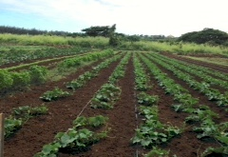 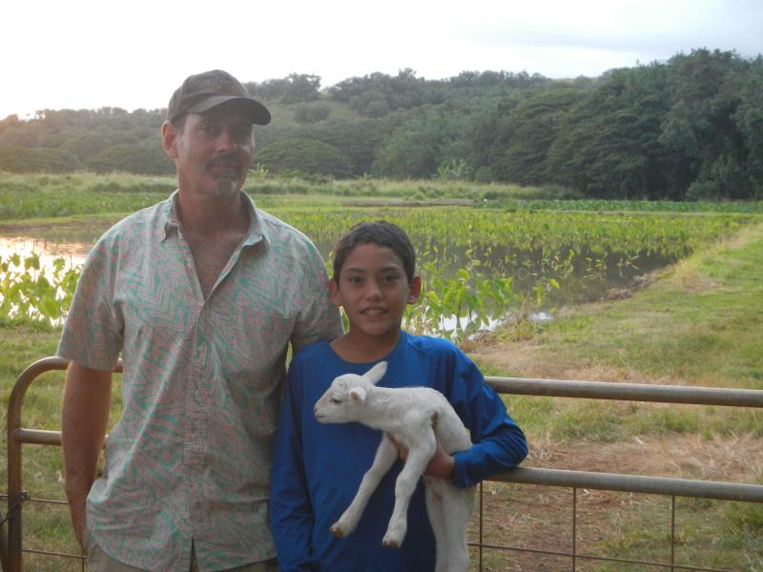

### 

### After the soaring experience of Koke’e come down to earth at **Kealia Farm** where you can taste the goodness of Kaua’i. They are real farmers, growing real food, to feed their families, friends and visitors.

There, you can walk around tasting tropical fruits and vegetables. Visit the farmer’s market on the farm and buy some fresh fruits and vegetables, picked daily, for your dinner.

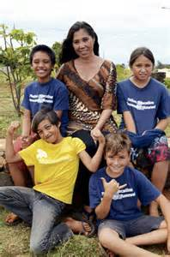 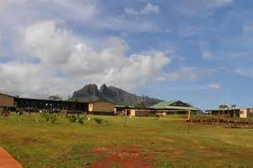 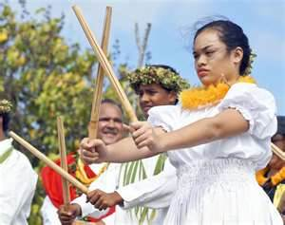 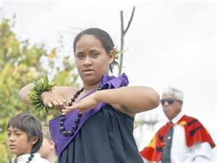

Upon finishing your visit to Kealia Farm, we will visit the **Anahola charter school** dedicated to the preservation of Hawaiian life and culture. This school welcomes all students who want to learn about and to treasure Hawaiian language, culture and traditions. The school provides and education for students from the age of 6 to 18.

Here we will stop for a demonstration of Hawaiian song, dance, art and perhaps canoe making. The children and the teachers of this school will be delighted to share their knowledge of all things Hawaiian.

A little further down the coast we find the **Kilauea Herb Garden**. This is a wonderful Garden through which to wander. The air is fragrant different herbs as you walk among the beautiful flowers and greenery.

Here they make several different kinds of Natural Herb teas from herbs grown strictly on this farm and Kaua’i. Each of these teas are organic and fresh. Each tea is dedicated to a particular part of your life.

There is one to help you wake up, another to help you sleep, one to help you be calm, one to give you more energy and one for your love life. Of particular interest is the Mamaki tea they make which is a traditional Hawaiian tea that is taken daily to maintain health and stamina. It is also good for stomach ailments and colds.

Please try a tea tasting and compare the teas. Enjoy a delicious, satisfying cup of tea while you view the gardens. Tea is also available for sale.

**Hanalei Farmers Market** is locally known is one of the beautiful settings for a community market and a must-see experience when you are on the island of Kauai. Dozens of local farmers sell a variety of unique **organic produce** and stunning **tropical flowers** as well as products such as crafts and more in a festive and colorful outdoor atmosphere.

Local farmers travel around the island and offer a variety of goods that will enhance your taste for the islands. Enjoy a refreshing **ice cold coconut** out of a straw, the strange looking but delicious rambutan fruit, juicy mangoes, sunrise papayas and the unforgettable apple bananas. The variety of greens and herbs is better here than in any grocery store on island. Live and eat healthy while supporting **local farmers** as well as helping Kauai become more self sustainable.

**[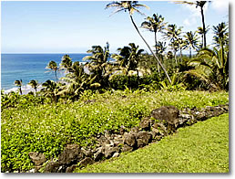](http://www.kaimi.org/wp-content/uploads/2014/04/heiau_kee.jpg)** 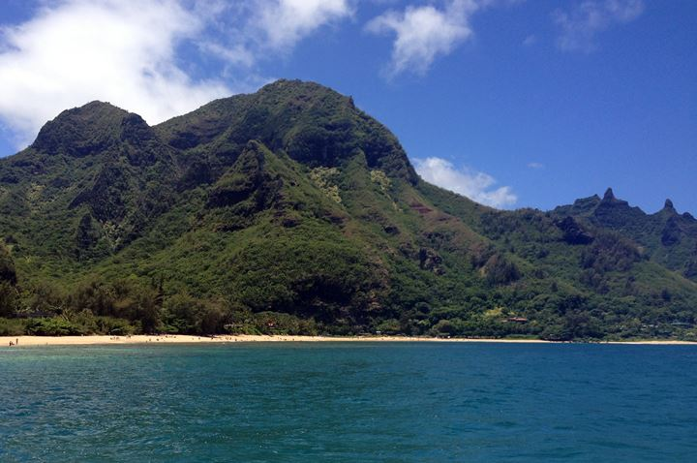

There is much to be discovered in Haena on Kauai's majestic North shore. You will discover some of the most spectacular scenery on the island.

Located high up on a terrace above big boulders in Haena is Ke ahu a laka Heiau that was part of a famous hula school. Chanters came to receive the most advanced training possible. To test their skills, they walked across the smooth boulders at the edge of the ocean and chanted their mele (chant). If their voices could be heard above the sounds of the ocean waves and the wind, their training was completed. Students are still brought to this Kauai Heiau to test their skills. If permitted, we will make a pilgrimage to this site.

Because of its association with the Pele-Hi’iaka-Lohi’au cycle of stories, na po’e hula (hula people) consider Ke’e one of the most important sites in all Hawai’i. These tales tell of Pele’s journey to Kaua’i in spirit form, her meeting with Lohi’au during a dance at Ke’e, and her sister Hi’iakaikapoliopele’s subsequent voyage to bring Lohi’au back to Pele’s home at Kilauea, Hawai’i.